WELCOME TO
ST. MARK’S EPISCOPAL CHURCH
✠
CAPITOL HILL

ST. MARK’S MISSION STATEMENT

St. Mark’s is an open community, welcoming people wherever they are on their faith journey. We celebrate the gifts of God that empower us to engage boldly in life's struggles and care for others with love, justice, and compassion.

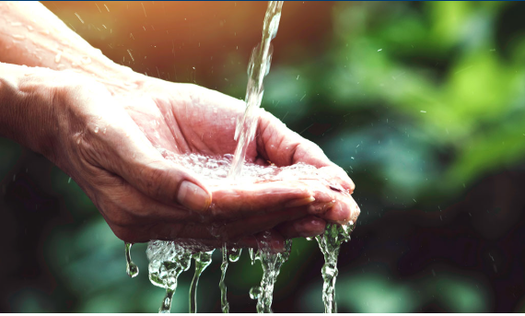

MID-LENT
LAETARE SUNDAY

March 15, 2026

5:00 PM HOLY EUCHARIST
& LAYING ON OF HANDS

Rector
The Reverend Michele H. Morgan

Associate Rector
The Reverend Caitlin Frazier

Pastoral Associate
The Reverend Patricia Catalano

Seminarian
Rebekah Taylor

Director of Music
Jeff Kempskie

Children, Youth, & Family
Ministry Director
Lisa Ramish

Welcome to St. Mark’s Episcopal Church ✠ Capitol Hill

To view the parish calendar online, please visit our homepage www.stmarks.net and click “Calendar” at the top of the page.

Hearing – Infrared headsets providing amplified sound are in the tract racks by the doors, or ask an usher.
Restrooms are available in the foyer, with more downstairs.

✠ ✠ ✠

THE LITURGY OF THE WORD

OPENING SENTENCES

Listen to the silence.
Hear the Voice of all;
The still, small Voice.
The Voice of God.

Silence is observed.

Seek the silence.
Find the Source of all.
That still, small Voice.
The Voice of God.

Silence is observed.

Welcome the silence.
Live in the Center of all;
The still, small Voice.
The Voice of God.

A period of silence is observed.

THE COLLECT

Let us pray

Gracious Father, whose blessed Son Jesus Christ came down from heaven to be the true bread which gives life to the world: Evermore give us this bread, that he may live in us, and we in him; who lives and reigns with you and the Holy Spirit, one God, now and for ever. Amen.

THE FIRST READING Ephesians 5:8-14

Once you were darkness, but now in the Lord you are light. Live as children of light— for the fruit of the light is found in all that is good and right and true. Try to find out what is pleasing to the Lord. Take no part in the unfruitful works of darkness, but instead expose them. For it is shameful even to mention what such people do secretly; but everything exposed by the light becomes visible, for everything that becomes visible is light. Therefore it says,

“Sleeper, awake! Rise from the dead, and Christ will shine on you.

Hear what the Spirit is saying to us.
Thanks be to God.

THE GOSPEL John 9:1-41

The Gospel of Jesus according to John.
Glory to you, Lord Christ.

As Jesus walked along, he saw a man blind from birth. His disciples asked him, “Rabbi, who sinned, this man or his parents, that he was born blind?” Jesus answered, “Neither this man nor his parents sinned; he was born blind so that God’s works might be revealed in him. We must work the works of him who sent me while it is day; night is coming when no one can work. As long as I am in the world, I am the light of the world.” When he had said this, he spat on the ground and made mud with the saliva and spread the mud on the man’s eyes, saying to him, “Go, wash in the pool of Siloam” (which means Sent). Then he went and washed and came back able to see. The neighbors and those who had seen him before as a beggar began to ask, “Is this not the man who used to sit and beg?” Some were saying, “It is he.” Others were saying, “No, but it is someone like him.” He kept saying, “I am the man.” But they kept asking him, “Then how were your eyes opened?” He answered, “The man called Jesus made mud, spread it on my eyes, and said to me,
‘Go to Siloam and wash.’ Then I went and washed and received my sight.” They said to him, “Where is he?” He said, “I do not know.”

They brought to the Pharisees the man who had formerly been blind. Now it was a sabbath day when Jesus made the mud and opened his eyes. Then the Pharisees also began to ask him how he had received his sight. He said to them, “He put mud on my eyes. Then I washed, and now I see.” Some of the Pharisees said, “This man is not from God, for he does not observe the sabbath.” But others said, “How can a man who is a sinner perform such signs?” And they were divided. So they said again to the blind man, “What do you say about him? It was your eyes he opened.” He said, “He is a prophet.”

The Jews did not believe that he had been blind and had received his sight until they called the parents of the man who had received his sight and asked them, “Is this your son, who you say was born blind? How then does he now see?” His parents answered, “We know that this is our son, and that he was born blind; but we do not know how it is that now he sees, nor do we know who opened his eyes. Ask him; he is of age. He will speak for himself.” His parents said this because they were afraid of the Jews; for the Jews had already agreed that anyone who confessed Jesus to be the Messiah would be put out of the synagogue. Therefore his parents said, “He is of age; ask him.”

So for the second time they called the man who had been blind, and they said to him, “Give glory to God! We know that this man is a sinner.” He answered, “I do not know whether he is a sinner. One thing I do know, that though I was blind, now I see.” They said to him, “What did he do to you? How did he open your eyes?” He answered them, “I have told you already, and you would not listen. Why do you want to hear it again? Do you also want to become his disciples?” Then they reviled him, saying, “You are his disciple, but we are disciples of Moses. We know that God has spoken to Moses, but as for this man, we do not know where he comes from.” The man answered, “Here is an astonishing thing!
You do not know where he comes from, and yet he opened my eyes. We know that God does not listen to sinners, but he does listen to one who worships him and obeys his will. Never since the world began has it been heard that anyone opened the eyes of a person born blind. If this man were not from God, he could do nothing.” They answered him, “You were born entirely in sins, and are you trying to teach us?” And they drove him out.

Jesus heard that they had driven him out, and when he found him, he said, “Do you believe in the Son of Man?” He answered, “And who is he, sir? Tell me, so that I may believe in him.” Jesus said to him, “You have seen him, and the one speaking with you is he.” He said, “Lord, I believe.” And he worshiped him. Jesus said, “I came into this world for judgment so that those who do not see may see, and those who do see may become blind.” Some of the Pharisees near him heard this and said to him, “Surely we are not blind, are we?” Jesus said to them, “If you were blind, you would not have sin. But now that you say, ‘We see,’ your sin remains.”

The Gospel of Jesus.
Praise to you, Lord Christ.

SERMON The Reverend Caitlin Frazier

MUSIC FOR MEDITATION

NICENE CREED

We believe in one God,
the Father, the Almighty,
maker of heaven and earth,
of all that is, seen and unseen.

We believe in one Lord, Jesus Christ,
the only Son of God,
eternally begotten of the Father,
God from God, Light from Light,
true God from true God,
begotten, not made,
of one Being with the Father;
through him all things were made.

For us and for our salvation
he came down from heaven,
was incarnate of the Holy Spirit and the Virgin Mary
and became truly human.
For our sake he was crucified under Pontius Pilate;
he suffered death and was buried.

On the third day he rose again
in accordance with the Scriptures;
he ascended into heaven
and is seated at the right hand of the Father.
He will come again in glory to judge the living and the dead,
and his kingdom will have no end.
We believe in the Holy Spirit, the Lord, the giver of life,
who proceeds from the Father,
who with the Father and the Son is worshiped and glorified,
who has spoken through the prophets.

We believe in one holy catholic and apostolic Church.
We acknowledge one baptism for the forgiveness of sins.
We look for the resurrection of the dead,
and the life of the world to come. Amen.

A period of silence is observed.

PRAYERS OF THE PEOPLE

Let us pray for the Church, ourselves, and the world.

Gracious God: As we walk through this season of Lent, we give thanks for our chosen spiritual home, all who guide and work for it, here and abroad.
Our help comes from you.

Creator God, who breathed this world into being and established a covenant with those who follow you: bring us out of the captivity of our lives into your promised land.
Our help comes from you.

Forgiving God, you entrusted to us this world of wonder and delight, yet we so often use it for our own glory rather than yours. Awaken us to its beauty, to its fragility, and to our call to speak and act for its healing.
Our help comes from you.

Loving God, you hold every life as precious. We pray for everyone affected by the conflict among Iran, Israel, and the United States, for the dead and the grieving, the fearful and the displaced. Do not let us look away from their suffering. Turn our hearts and our leaders toward peace, and renew in us compassion and courage.
Our help comes from you.

Loving God, you taught that none are forgotten in your sight. Be near to the lonely, the isolated, and the weary. Carry us all through these dark days, and breathe new life into us, as you breathe new life into the earth each spring.
Our help comes from you.

Living God, your Son walked among us and touched those the world overlooked.
Help us remember the unhoused, the refugee, and the stranger, and remind us that we are your hands in the world.
Our help comes from you.

Comforting God, you welcomed your Son home after his earthly life.
Welcome into your embrace all those we have loved and lost, those we remember and those we do not, those known and those forgotten, and remind us that one day we too shall be welcomed home.
Our help comes from you.

Let us pray for our own needs and those of others.

Community members may now oﬀer petitions ending with
“This is my prayer,” to which all will respond, “Amen.”

Merciful God, grant that what we, your servants, have prayed for, we may have grace to work for; and in the purpose of your love, answer our prayers and fulfill our hope.
Amen.

CONFESSION
Let us confess our sins against God and our neighbor.

Silence is observed.

Together,
Forgiving God,
we have sinned against you;
we have done evil in your sight.
We are sorry and repent.
Have mercy on us according to your love.
Wash away our wrongdoing and cleanse us from our sin.
Renew a right spirit within us
and restore us to the joy of your salvation,
through Jesus Christ our Lord. Amen.

ABSOLUTION

God forgives you, forgive yourself and go in peace.

THE PEACE
May the peace of God be with you!
And also with you.

VESTRY GREETING

WELCOME

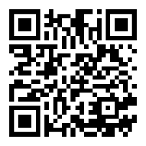
ELECTRONIC OFFERING

Please consider supporting the work of the church. You may make an online gift, or learn about the other ways to give, by visiting the St. Mark’s website, stmarks.net, and choosing “Donate or Pledge” at the top.

Gifts to St. Marks can also be made by texting “stmarks20003” to 73256, or by visiting the QR code. Thank you for your generous support of our collective work.

Food offerings may be brought forward to the baskets under the altar at this time.

OFFERTORY SENTENCE
Offer to the Holy One a sacrifice of Thanksgiving and make good your vows to the Most High. (Psalm 50:14)

THE LITURGY OF THE TABLE

EUCHARISTIC PRAYER

God be with you.
And also with you.

Lift up your hearts.
We lift them to God.

Let us give thanks to God.
It is right to give our thanks and praise.

Eternal God, in the abundance of your love, you have caused all things to be; from dust and spirit you have woven our humanity; in all our wanderings, you never cease to call us to fullness of life.
You gave us Jesus, son of Mary, the bread of life broken for the world; he fed us and feasted with us, suffering with us, in his dying and rising, sharing with us the pattern of our living.

Therefore, with all whom you have made, cherished, and called, with all who hunger for your kingdom and will not rest until all your children are fed, with the broken saints and redeemed sinners of all the ages, we take up the song of your praise:

Holy, Holy, Holy Lord, God of power and might,
heaven and earth are full of your glory.
Hosanna in the highest.
Blessed is the one who comes in the name of the Lord.
Hosanna in the highest.

We ask that your Holy Spirit fall upon us and upon these gifts that these fragile, earthly things may be to us the body and blood of our lord and brother, Jesus Christ; who, on the night that he was betrayed, gathered with his faltering friends for a meal that tasted of freedom.

Calling them to his table, he took bread, gave thanks, broke it, and said, “This, my body, I give to you. Eat and remember me.” In the same way, after supper, he took the cup, saying: “This, my blood, I give to you. Drink and remember me.”

As on that night, so here and now he offers himself in touch and taste beyond all words can hold. Great is the mystery of faith.

Christ has died. Christ is risen. Christ will come again.

Therefore, in our eating and drinking, we are filled with Jesus’ life-giving presence; we proclaim him as creation’s host, transforming poverty into plenty in the reckless generosity of love.

Inspire us with the hope that one day death and greed will be no more and people without number will come from east and west, north and south to share the kingdom meal. Amen.

THE LORD’S PRAYER

And now, as Jesus taught us, let us pray:
Our Father, who art in heaven, hallowed be thy Name,
thy kingdom come, thy will be done, on earth as it is in heaven.
Give us this day our daily bread.
And forgive us our trespasses, as we forgive those who trespass against us.
And lead us not into temptation, but deliver us from evil.
For thine is the kingdom, and the power, and the glory, for ever and ever. Amen.

THE FRACTION

Christ our Passover is sacrificed for us;
Therefore, let us keep the feast.

THE INVITATION TO COMMUNION

We recognize this as God’s table and this bread and wine as God’s food for us all.

Therefore, whoever we are, from wherever we have come, and whatever we believe or do not believe, All are welcome and invited to receive. Amen!

THE COMMUNION

St. Mark’s receives communion “in the round” as a symbol of our
strong belief in the power of community.

You will be offered bread by a celebrant and invited to drink from the common cup. Please put out your hands to help guide the cup to your lips, and drink.

If you do not wish to receive the wine, please cross your hands over your chest. Please refrain from intincting (dipping) the host (the bread) into the wine.

We offer Laying on of Hands in the chapel on the first and third Sunday of the month. On those Sundays, you may receive communion and go to the chapel to have prayers.
MUSIC DURING COMMUNION

POST-COMMUNION PRAYER

Together, let us pray.
Lord of this feast beyond measure and price: we thank you for meeting us in our brokenness so that none might be lost: liberate us now to share bread with our neighbor, each receiving from the other what we need to be ourselves. Amen.

THE BLESSING

May our wilderness bear no terror for us, only truth. May our truth never break us,
only make bold our strength. May we, in our strength, seek not to sustain only yourselves but make swift our service to others. And may the blessing of God –Creator, Redeemer, Sustainer – shine in us and through us, this day and always.
Amen.

DISMISSAL

In this season of contemplation, let us move into a world
In which we bring all of ourselves

Go in peace, to love and serve God.
Thanks be to God.

✠ ✠ ✠

Liturgical Leaders and Worship Participants

We'd love to talk to you if you’re interested in serving in the liturgy in any of the following roles!
For more information, contact our Assistant Rector Caitlin Frazier, Caitlin@stmarks.net

Ministers All the Members of St. Mark’s
Presider & Preacher The Reverend Caitlin Frazier
Verger Martha Huizenga
Laying on of Hands Jillian McGreen

Acknowledgements: Opening Sentences: Lisa Frenz 1999. The Collect: The Book of Common Prayer. Prayers of the People: Saint Mark's Common Usage. Eucharistic Prayer: Prayers for an Inclusive Church -- Eucharistic Prayer I. Post-communion Prayer, The Blessing: Prayers from an Inclusive Church by Steven Shakespeare. The Dismissal: The Rev. Michele H. Morgan

As we move into the season of Lent, you will notice several changes: the cross over the altar is the broken mirror cross created by the late Joya Cox symbolizing our broken nature. All the silver is stored until Easter: the offering plates, alms basin; the candlesticks on the altar are wood and our chalices are pottery. The acolytes wear Jerusalem crosses made of olive wood from Bethlehem on purple ribbons. The hangings on the pulpit, lectern and altar are purple, the color of penitence, as are the stoles worn by the clergy. All crosses are draped in purple until Holy Week when the color changes to red.

✠ ✠ ✠

Land Acknowledgement We acknowledge with respect the history, spirituality, and culture of the peoples on whose traditional territory we are located, specifically the Piscataway and Nacotchtank (Anacostan) peoples. We make this acknowledgment mindful of the traumatic events and the ongoing forces of systemic racism and oppression that forced native peoples from their lands. We continue our commitment to learning, growing, and finding a new way forward for meaningful, mutual healing.

Holy Week and Easter Services

Palm Sunday, March 29
9:00 a.m. Liturgy of the Palms
10:00 a.m. Sermon Seminar
11:15 a.m. Liturgy of the Palms (service live-streamed)
5:00 p.m. Liturgy of the Palms

Tenebrae, Wednesday, April 1
7:00 p.m. A solemn candlelit service of Scripture and shadows,
remembering Christ’s Passion

Maundy Thursday, April 2
6:30 p.m. Reception
7:00 p.m. Dinner in Parish Hall
8:00 p.m. Holy Eucharist (service live-streamed)

Good Friday, April 3
12:00 p.m. Good Friday Service
3:00 p.m. Stations of the Cross at the U.S. Capitol
7:00 p.m. Good Friday Service

Special Service, April 4
10:00 a.m. Walking after Jesus, Interactive Children's Holy Week Service

Easter Sunday, April 5
9:00 a.m Festival Eucharist
10:30 a.m. Easter Egg Hunt and Potluck Brunch
11:15 a.m. Festival Eucharist with incense (service live-streamed)
5:00 p.m. Contemplative Eucharist

Cycle of Prayer

In the Diocese of Washington

St. Patrick’s Church, DC • St. Patrick’s Episcopal Day School, DC

Anglican Communion

The Anglican Church of Kenya

Parish Prayer List

Ben Alquiros • Nora Alquiros • Pam Baugh • Alex Beau • Jackie Boddie
Joseph Boone • Suzanne Burnette • Tracy Councill
Mark, Karen, Abby & Aimee Dahl • Martin & Mary De Nys • Charley Donnelly
Pete Eveleth • Karen Falk • Rudy Grube • Jack Guza • Dianne Hall • Barbara Harvey Michael Henely • Jack Howell • Gale Johnson • Julia Jones • Liam Kenny
Shadi Khoury • Hatcher Byrd Kincheloe • Pat Latin • Marwan Ibrahim Maadi
Lila Marks • Nat Marks • Taylor Emerson Marks • Sis Mckay • Walt Moody
Fred Muller (and family) • Delia Neuman (and family) • Hester Ohbi
Malik Robinson Jr • Charlie Rupp • T.H. Salmon • Ben Schaibly • Bob Schaaf
Stephanie Seely • Elin Whitney Smith • Richard Smith • Helen Soheilli
Martha Kincheloe Spain • Suzanne Stepanek Spratt • Barbara Starkey
Deb Sullivan • Anthony Sullivan • Yasser & Jawaher Toshtash • David Thacker
Carol Thornhill • Stephanie Toth • Stephen Wolf • Geoffrey Wood • Tom Zarek

Parishioners and Family Members Serving in the Military

Chase Allen Ammon • Clint Billings • Jason Earnest • Noah Landen
Ensign Andrew Loevinger • Lt. Tyler Gray-Hoehn • 1st Lt. Colin Gray-Hoehn

If you would like to request to add or remove a name,
please email the Bulletin Coordinator at bulletin@stmarks.net

St. Mark’s Episcopal Church, Capitol Hill

301 A Street, SE

Washington, DC 20003

202-543-0053
www.stmarks.net

Office Directory

The Reverend Michele H. Morgan, Rector michele@stmarks.net
The Reverend Caitlin Frazier, Associate Rector caitlin@stmarks.net
The Reverend Patricia Catalano, Liturgy & Pastoral Associate adjunct@stmarks.net
Rebekah Taylor, Seminarian seminarian@stmarks.net
Jeff Kempskie, Director of Music jeff@stmarks.net
Lisa Ramish, Children's, Youth, & Family Ministry Director youthdirector@stmarks.net
Samantha White, Parish Administrator for Building and Facilities parishadmin@stmarks.net
Annick Milde, Parish Administrator for Finance pfa@stmarks.net
Judith Rautenberg, Children’s Choir Director judith@stmarks.net
Katherine Philipson, Bulletin Coordinator bulletin@stmarks.net

The Vestry

Senior Warden Alix Pereira srwarden@stmarks.net
Junior Warden Martha Huizenga juniorwarden@stmarks.net

Class of ‘27 Elizabeth Becker, Kristina Keenan & Doug Padgett
Class of ‘28 Mary Ellison, Ben Flowers, Katherine White
Class of ‘29 Laura Gladstone, Randy Marks, Bo Ranney

Officers
Doug Ammon, Treasurer
Roy Phillips, Asst. Treasurer
Nick Simons, Risk Manager
Ryan Baugh, Clerk
Karen Wiedemann, Vestry Counsel

Diocesan Delegates
J.R. Randall (2027), Mary Neznek (2027), Jan Lipscomb (2028), Michael Knipe (2029)

Upcoming Vestry Meetings will be held on March 24th 7:00 PM via Zoom and in-person. If you have questions, contact the Vestry Clerk at clerk@stmarks.net

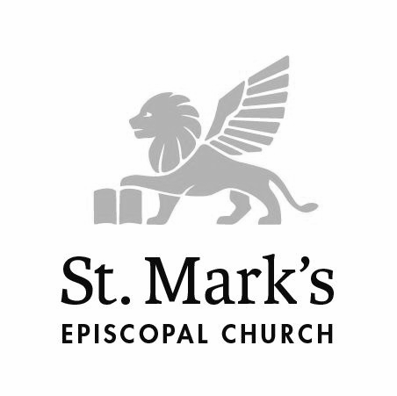
Welcome Guests!
We’d like to get to know you better!

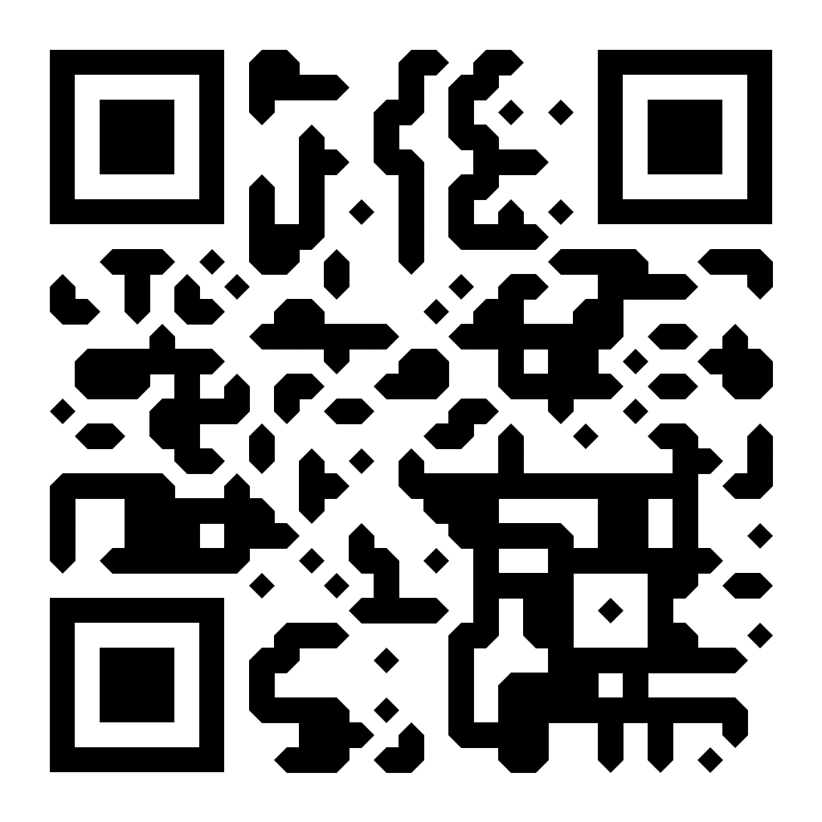
We invite you to fill out this page, tear it off, and drop it into the offering plate or hand it to one of the greeters as you leave. If you have questions, please speak with the clergy or one of the greeters after the service.

To complete this form online, or sign up for our
weekly newsletter, use this QR code:

I attended: | _____ 5 p.m. Worship Service on March 15, 2026
Name ___________________________________________________________
E-mail ___________________________________________________________
Phone No. ___________________________________________________________
Zip Code ___________________________________________________________

I am interested in learning more about:

_____ Becoming a member
_____ Service and Social Justice
_____ Adult education classes and prayer groups
_____ Volunteer during worship (Greet, Lay Serve, Altar Guild, Read, etc.)
_____ Baptism/Confirmation (child, adult)
_____ Music (choir, lessons)
_____ Children/youth classes & programs including Sunday School
_____ Affinity groups (20s/30s, Men’s Group, Women’s Group)
_____ Getting married at St. Mark’s
_____ Meditation Center
_____ Yoga classes
_____ Dance classes
_____ St. Mark’s Players (theatrical productions)

Anything else you would like to share?
_________________________________________________________________________
_________________________________________________________________________
Thank you for visiting St. Mark’s today. Go in peace and return often!

